Name : Shahil . S . Pathan
Roll No. : 132
Subject : Data Analytics Using Python
T.Y B.C.A - C

EDA Practical Homework Assignments

Practical 1: Load and Explore a Dataset
* Load any CSV dataset (e.g., Titanic or
Iris).
* Display the first 5 rows.
=> import pandas as pd
import numpy as np
import matplotlib.pyplot as plt
import seaborn as sns

df = sns.load_dataset('titanic')
df.head()

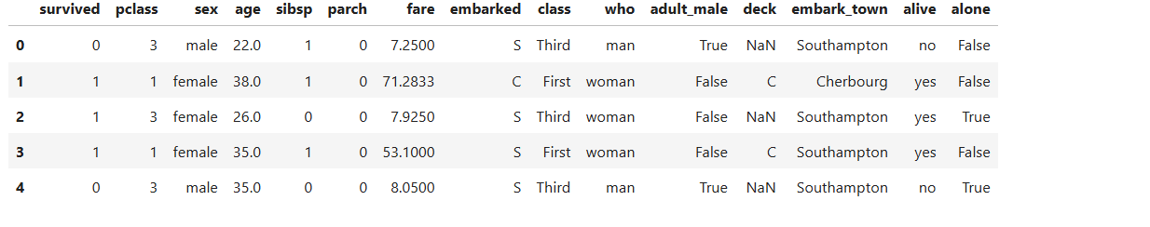
* Display the last 5 rows.
=> df.tail()

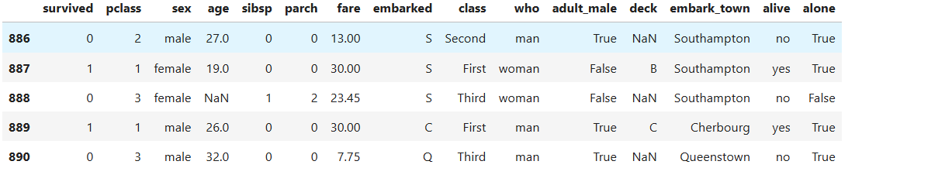

* Show basic info using .info() and .describe().
=> df.info()
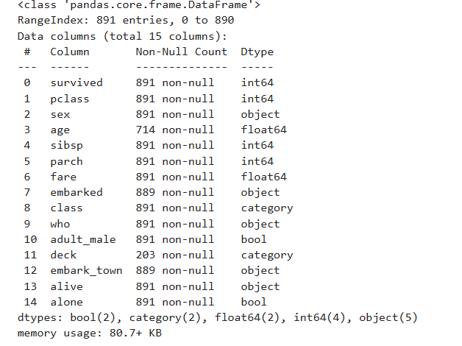

=> df.describe()
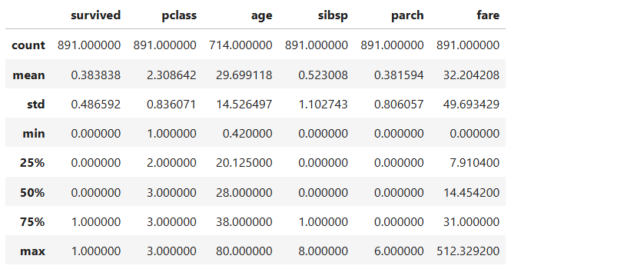
* Count missing values column-wise.
=> df.isnull().sum()
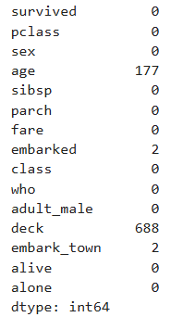

Practical 2: Univariate Analysis
* Choose one numerical and one categorical column.
Numerical Column → age
Categorical Column → sex
* Perform descriptive statistics (mean, median, mode, std).
=> df['age'].mean()

=> df['age'].median()

=> df['age'].mode()
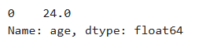
=> df['age'].std()

* Draw:
o Histogram (age)
=> df = sns.load_dataset('titanic')

plt.hist(df['age'].dropna())
plt.title("Age Distribution")
plt.xlabel("Age")
plt.ylabel("Frequency")
plt.show()

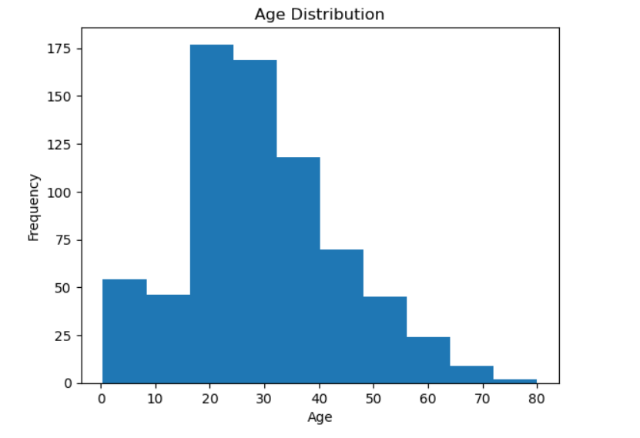
o Box plot (age)
=> plt.boxplot(df['age'].dropna())
plt.title("Boxplot of Age")
plt.show()
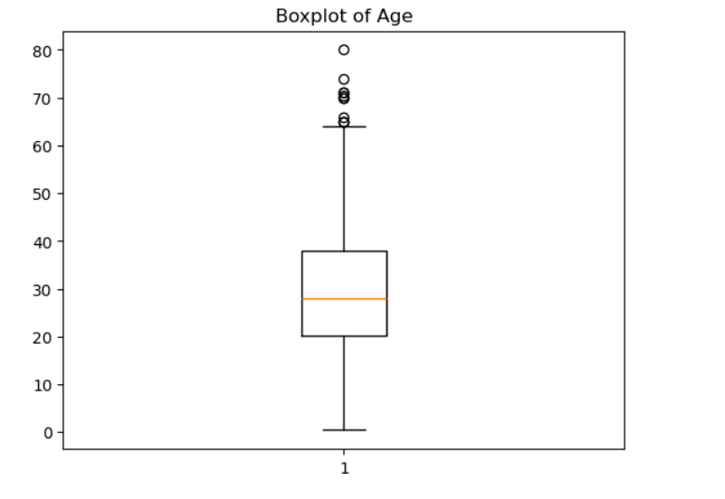
o Pie chart (for categorical column) (sex)
=> df['sex'].value_counts().plot.pie(autopct='%1.1f%%')
plt.title("Gender Distribution"
plt.ylabel("")
plt.show()
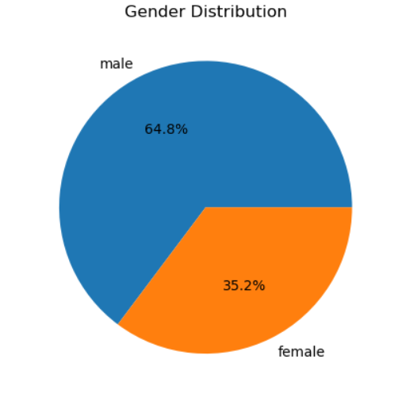
Practical 3: Bivariate Analysis
* Select two columns (e.g., Age and Survival, or PetalLength and PetalWidth)
=> Columns → age & survived
* Plot:
o Scatter plot
=> df = sns.load_dataset('titanic')

plt.scatter(df['age'], df['survived'])
plt.xlabel("Age")
plt.ylabel("Survived")
plt.title("Age vs Survival")
plt.show()
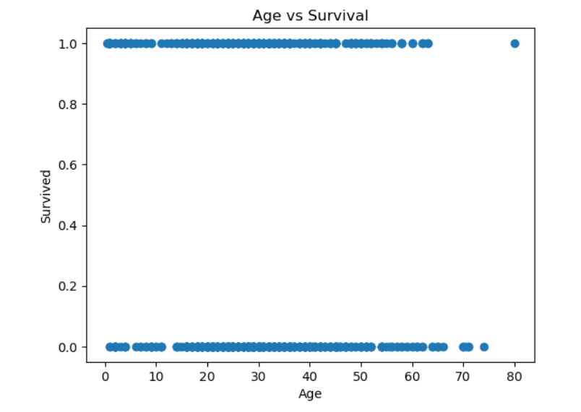
o Correlation matrix
=> corr = df[['age', 'fare', 'survived']].corr()
sns.heatmap(corr, annot=True)
plt.show()
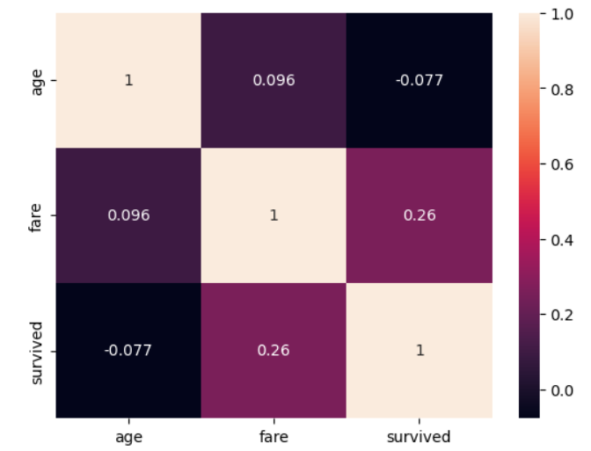
o Bar chart (for one numerical and one categorical)
=> sns.barplot(x='sex', y='survived', data=df)
plt.title("Survival Rate by Gender")
plt.show()
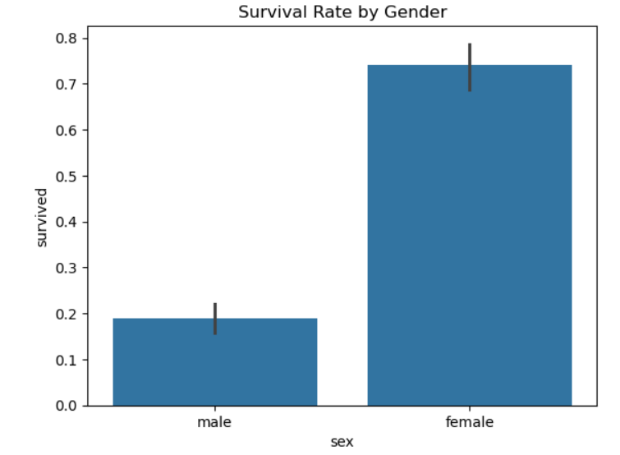Practical 4: Multivariate Analysis
* Use pairplot and heatmap to visualize relationships between multiple features.
=> sns.pairplot(df[['age', 'fare', 'survived']].dropna())
plt.show()
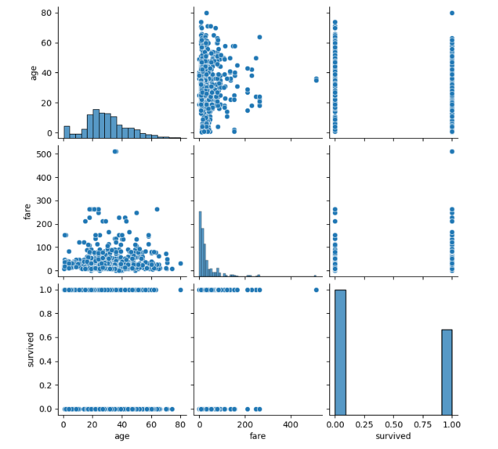
* Interpret at least two insights based on the heatmap.
=> sns.heatmap(df[['age', 'fare', 'survived', 'pclass']].corr(), annot=True)
plt.show()
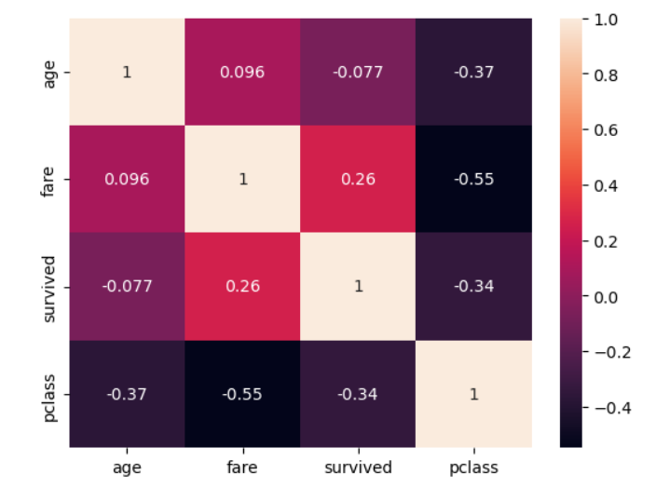
Practical 5: Handling Missing Data
*Identify columns with missing values.
=> df.isnull().sum()
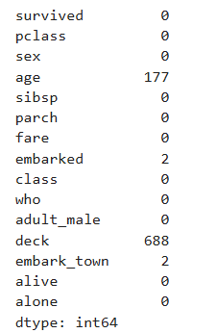
* Fill missing values using:
o Mean (for numeric columns)
o Mode (for categorical columns)
=> df['age'].fillna(df['age'].mean(), inplace=True)
df['embark_town'].fillna(df['embark_town'].mode()[0], inplace=True)
o Interpolation
=> df['fare'] = df['fare'].interpolate()
*Compare dataset before and after filling.
=> print(df.head())
print(df.isnull().sum())
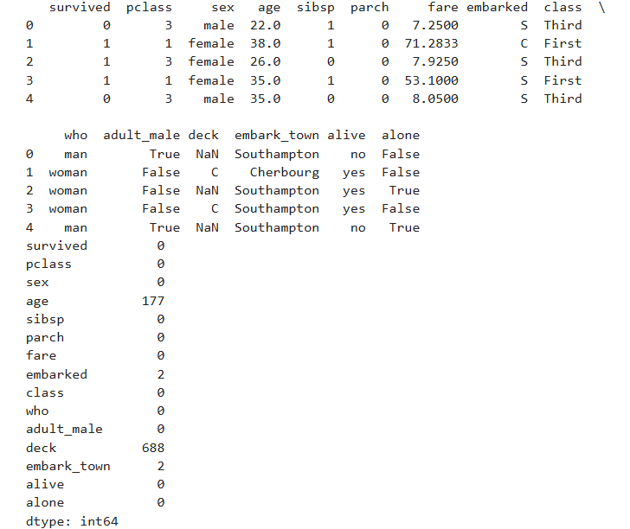
Practical 6: Detecting and Handling Outliers

* Use boxplots to detect outliers in any one numerical column.
=> plt.boxplot(df['fare'])
plt.title("Fare Outliers")
plt.show()
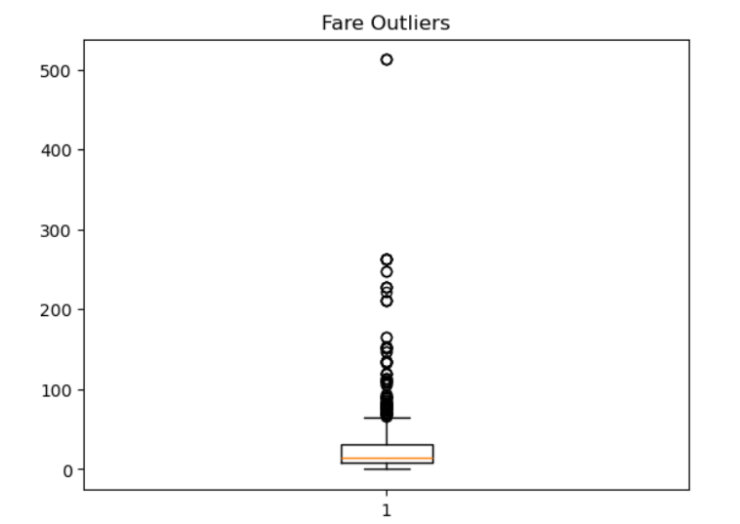

* Use IQR method to identify the outlier threshold.
=> Q1 = df['fare'].quantile(0.25)
Q3 = df['fare'].quantile(0.75)
IQR = Q3 - Q1

lower = Q1 - 1.5 * IQR
upper = Q3 + 1.5 * IQR

* Remove or cap the outliers.
=> df_clean = df[(df['fare'] >= lower) & (df['fare'] <= upper)]
* Show data before and after cleaning.
=> df.shape
df_clean.shape
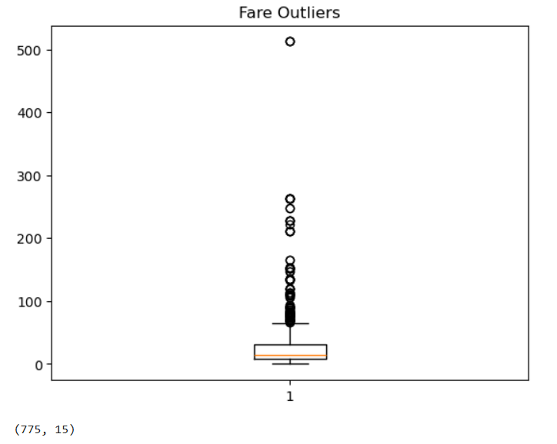

Practical 7: Mini-EDA Report
* Choose any dataset (small and public).
* Write a 1-page EDA report covering:

o Dataset summary
=> Dataset: Titanic
=> Rows: 891
=> Columns: 15
=>Target: survived

o At least 2 plots
=> Histogram of Age
=> Bar chart of Gender vs Survival
=> Heatmap correlation

o Missing value handling
=> Age → Mean
=> Embark_town → Mode
=> Fare → Interpolation

o Insights from bivariate/multivariate analysis
=> The survival rate of females was higher than that of males.
=> Passengers who paid higher fares had higher chances of survival.
=> Age had a weak impact on survival.

